LAB-1
  - HT.NO-2303a52470
BATCH-35

Task 1: prompt: “Generate Python code to reverse a string without using functions and take user input.”
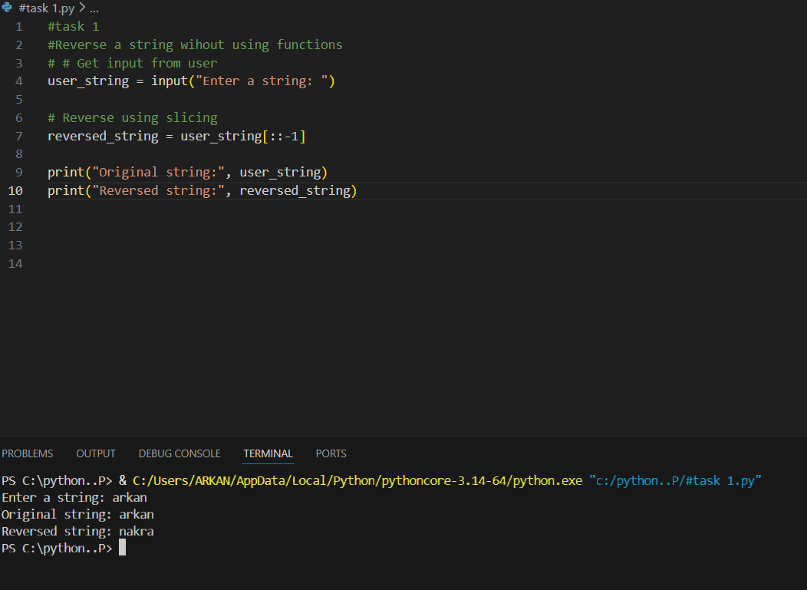

Task 2: prompt: “Simplify this string reversal code and improve readability and efficiency.”
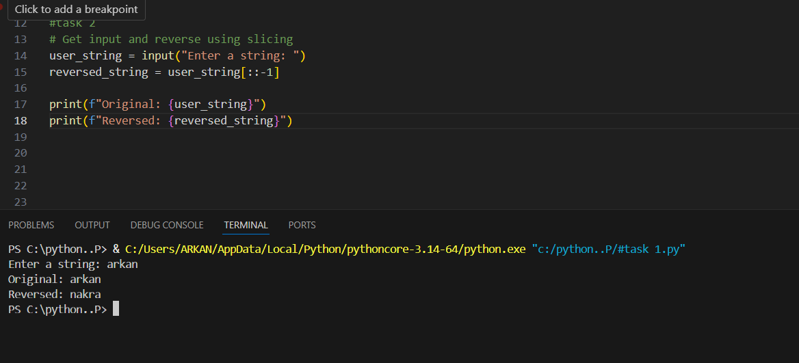

Task 3: prompt: Create a Python function to reverse a string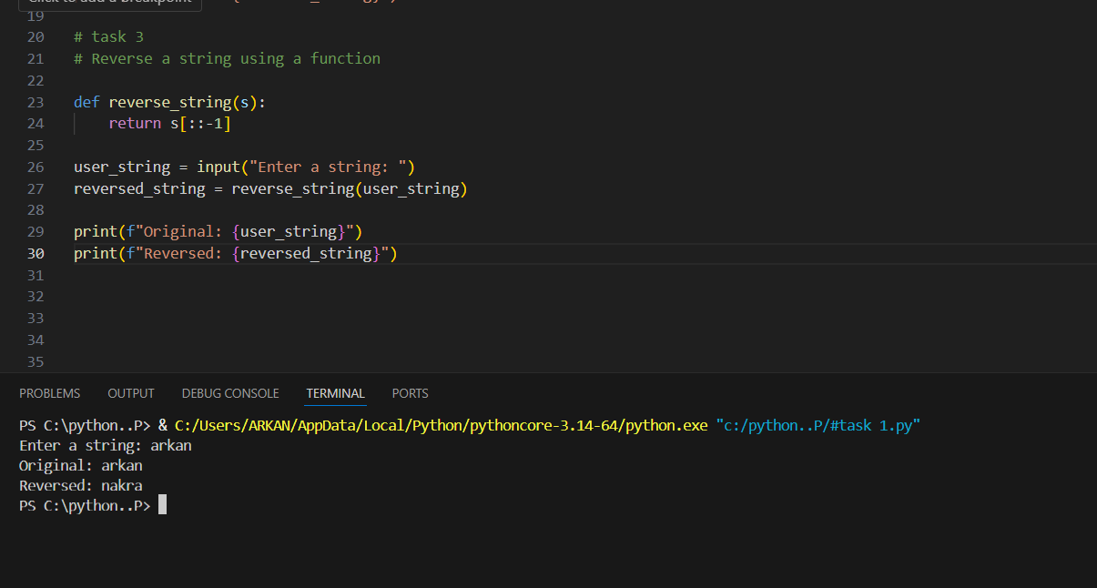

Task 4:
• Task 1 is best for quick scripts and beginners learning string slicing.
• Task 2 follows good programming practices such as modularity and abstraction.
• In real-world or large-scale applications, Task 2 is preferred because:
- It reduces redundancy
- Improves maintainability
- Makes testing and debugging easier

Task 5:prompt: • Reverse a string using a loop in Python”
• “Reverse a string using slicing in Python”
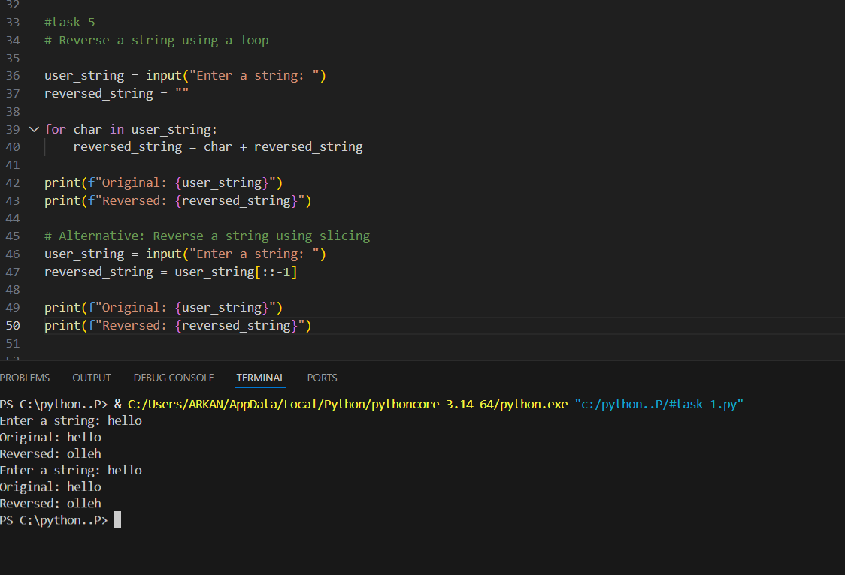

Execution Flow(Loops)
- Takes input from the user
- Iterates through each character in the string
- Prepends each character to build the reversed string step by step
- Prints the final reversed string
Execution Flow(slicing)
- Takes input from the user
- Uses Python slicing to reverse the string in one operation
- Prints the reversed string
- Final Conclusion
- While both approaches produce the same output, the slicing-based method is superior in terms of performance, readability, and scalability.
The loop-based method is mainly valuable for educational purposes.

